Mathematical Vocabulary

Year 6



Mathematics vocabulary list Year 6
Maths is its own language. Sometimes that language looks like the written word and sometimes it looks like symbols, but it is a language and it must be learned for mathematical fluency and competency. If your child does not have a good understanding of key mathematical vocabulary, it can hinder them in making good progress in maths and in other areas of the curriculum.
At The Pines, we explicitly teach maths vocabulary, giving it a context and allowing children to apply it in a variety of problems.
Listed below are the key mathematical terms your child will learn this year. This is the minimum we expect children to learn; however, we know children are curious and will undoubtedly want to learn more and we encourage this.
Vocabulary | Definition | Example
Number and Place Value

Brackets | The symbols ( ) used to separate parts of a multi-step calculation. | ‘(10 – 2) × 3 = 24’
Degree of accuracy | A description of how accurately a value is communicated. | ‘The degree of accuracy needed for the answer is one decimal place.’  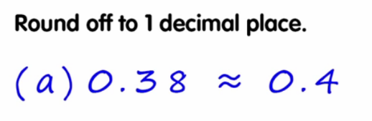
Equivalent expression | An expression, which can be algebraic, which is equal in value to another expression. | ‘Find an equivalent expression to 17 + 10. 18 + 9 is an equivalent expression to 17 + 10.  ‘
Order of operations | The internationally agreed  order to complete operations  in a multi-step equation with  multiple operations. | ‘(3 + 4) × 2 =  The order of operations dictates that the operation within the brackets is  completed first.’  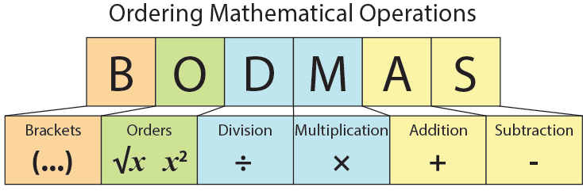
Addition and subtraction

Multiplication and division

Factorise | To identify factors of a given number. To express a number as factors. | ‘I can factorise 12 by looking at its factor pairs. 1 × 12 = 12, 2 × 6 = 12, 3 × 4 = 12. So the factors of 12 are 1, 2, 3, 4, 6 and 12.’
Prime factor | A factor that is a prime number.  In other words: any of the prime numbers that can be multiplied to give the original number | ‘The prime factors of 15 are 3 and 5 (because 3×5=15, and 3 and 5 are prime numbers)’.
Fractions, decimals, percentages

Ratio | A ratio shows the relative sizes of two or more values. | 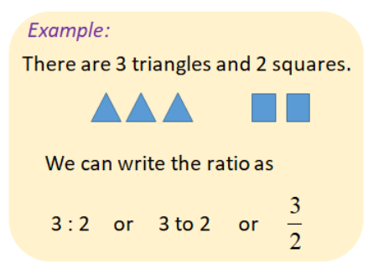
Proportion | A comparison between two or more parts of a whole or group. Proportion expresses a part-whole relationship. This may be represented as a fraction, a percentage or a decimal. | 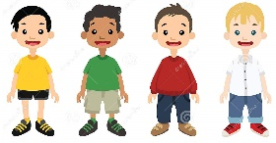    ‘Two thirds of a group of children were boys. The proportion of the group that is girls is one third.’
Algebra

Equation | An equation says that two things are equal.  It will have an equals "=" sign | ‘That equation says: what is on the left (7 + 2) is equal to what is on the right (10 − 1)’  7 + 2 = 10 - 1
Formula | An algebraic expression of a  rule. | ‘The area of a rectangle can be found by multiplying the width and height. a = w × h. This is the formula’.
Unknown | A number we do not know. | ‘In the equation below, y is unknown but can be calculated.  y + 17 = 100’
Variable | A symbol for a value we don't know yet. It is usually a letter like x or y. | 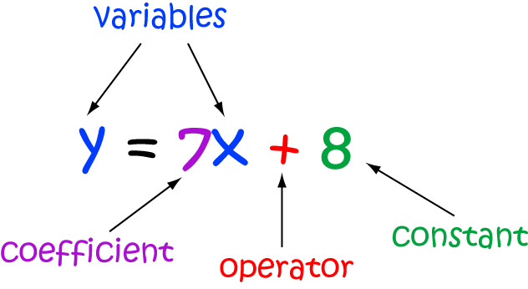
Length

Feet/foot | An imperial unit of measure of length. | ‘I am approximately five feet tall.’
Mile | An imperial unit of measure of length. | ‘Five miles is equivalent to eight kilometres.’
Yard | A unit of length (or distance) equal to 3 feet or 36 inches. | ‘In football, the penalty spot in 12 yards from the goal line.’
Weight

Ounce | An imperial unit of measure of mass. | ‘The new born baby had a mass of 6 pounds and 3 ounces’.
Tonne | A unit of mass equal to 1000 kilograms. | ‘A small car weighs about 1 tonne’.
Capacity and volume

Centilitre | A metric unit of capacity, equal to one hundredth of a litre | ‘There are 500 centilitres in this beaker. It is about the same 5 litres’.
Gallon | An imperial unit of measure of volume/capacity. | ‘A gallon is approximately 4.5 litres.’
Temperature

Time

British Summer Time | Time as advanced one hour ahead of Greenwich Mean Time for daylight saving in the UK between March and October. | ‘During British Summer Time, there are more daylight in the evening and less in the morning’.
Greenwich Mean Time | Greenwich Mean Time is an internationally standard time format. It is the main time zone in several countries, including the United Kingdom. | 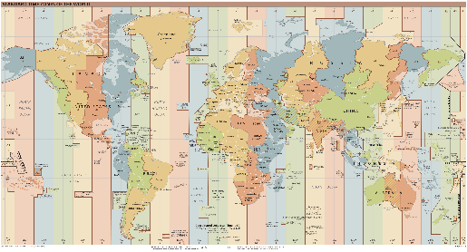
Money

Loss | If the income is less than the expenses. | ‘Two days ago. Sam's Bakery received $480, but expenses were $520.  $480 − $520 = −$40, which is a $40 loss’.
Profit | Income minus all expenses. | ‘Sam's Bakery received $900 yesterday, but expenses such as wages, food and electricity came to $650. So the profit was $900 − $650 = $250.’
2d shape

Arc | A portion of the circumference of a circle | 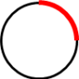
Circumference | The perimeter/boundary of a circle. | 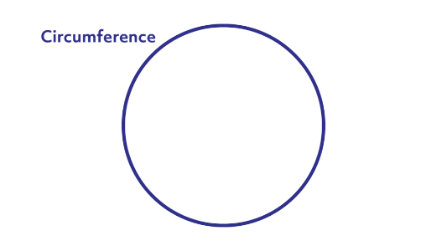
Compass | A tool for creating curved lines, arcs and circles. | ‘I can use a pair of compasses to draw a circle with a radius of 4 cm.  ‘
Intersect | The point at which two (or more) lines meet is where they intersect. | ‘The x and y axes intersect at (0,0)  ‘
Diameter | A line from one point of the circumference of a circle to another on the opposite side, which must pass through the centre of the circle. | 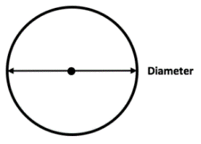
Radius | A line from one point of the circumference of a circle to the centre of the circle. | 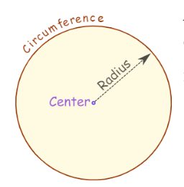
Similar | Similar shapes are those which have the same internal angles and where the side lengths are in the same ratio or proportion. Enlarging a shape by a scale factor (for example by doubling all side lengths) creates a similar  shape. | 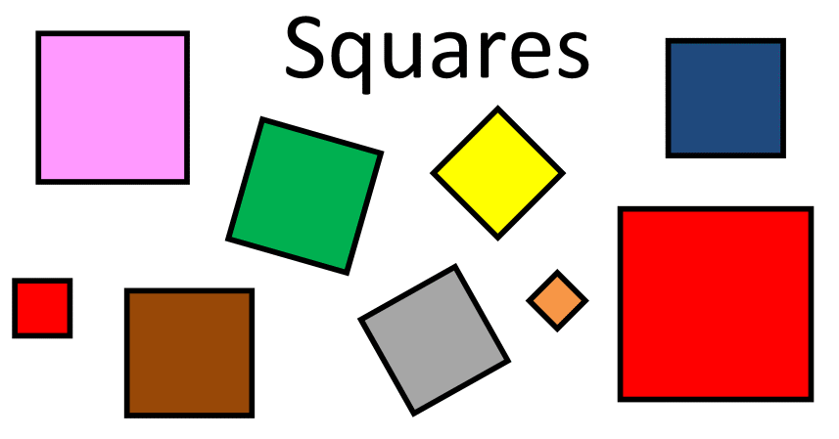  ‘All squares are similar to one another.’
3d shape

Dodecahedron | A polyhedron (a flat-sided solid object) with 12 Faces. | 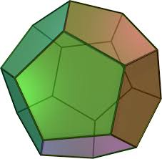
Net | A group of 2-D shapes which, when folded and connected,  forms a 3-D polyhedron. | 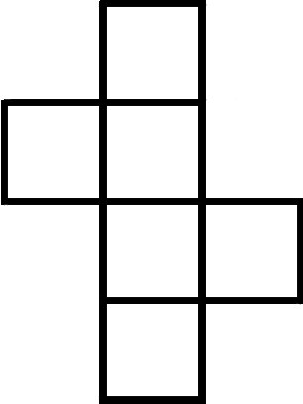  ‘The net of a cube is comprised of six connected squares.  ‘
Position and direction

Origin | The point at which axes in a coordinates grid cross; the point (0,0). | 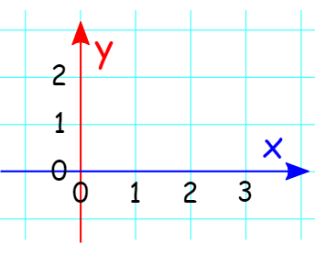
Vertically opposite angles | Angles which are positioned  opposite to one another when  two lines intersect. | 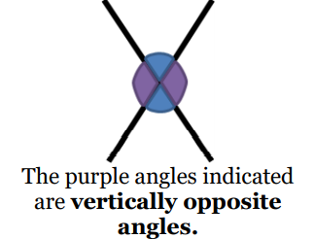
Statistics

Mean | The Arithmetic Mean is the average of the numbers: a calculated "central" value of a set of numbers.  To calculate it:  • add up all the numbers,  • then divide by how many numbers there are. | ‘What is the mean of 2, 7 and 9?  Add the numbers: 2 + 7 + 9 = 18  Divide by how many numbers (i.e. we added 3 numbers): 18 ÷ 3 = 6  So the mean is 6’.
Pie chart | A representation of a set of data where each segment represents one group in proportion to the whole. | 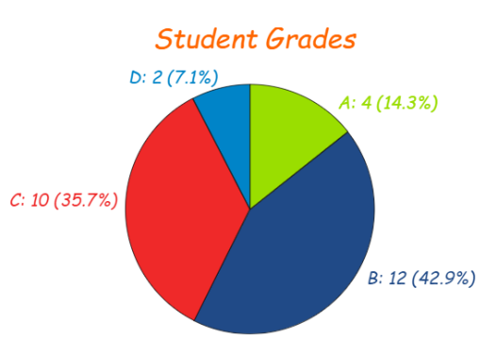
Statistics | The study of data: how to collect, analyse, summarise and present it. | 

