Mathematical Vocabulary

Year 2



Mathematics vocabulary list Year 2
Maths is its own language. Sometimes that language looks like the written word and sometimes it looks like symbols, but it is a language and it must be learned for mathematical fluency and competency. If your child does not have a good understanding of key mathematical vocabulary, it can hinder them in making good progress in maths and in other areas of the curriculum.
At The Pines, we explicitly teach maths vocabulary, giving it a context and allowing children to apply it in a variety of problems.
Listed below are the key mathematical terms your child will learn this year. This is the minimum we expect children to learn; however, we know children are curious and will undoubtedly want to learn more and we encourage this.
Vocabulary | Definition | Example
Number and Place Value

Calculate | To compute or work out mathematically. | ‘Can you calculate the answer to 13 + 4?  ‘
Column | A vertical arrangement of  numbers or objects. | ‘24 has two tens – I will place  them into the tens column’.  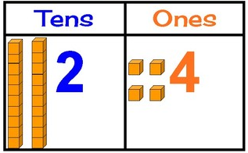
Continue | To carry something on. | ‘Can you continue this pattern?  15, 20, 25, 30, 35…’
Efficient | Well-organised. Choosing an  efficient computation strategy requires consideration of the numbers involved and will normally utilise ‘known facts’. | ‘I will use my number bonds knowledge to calculate 22 + 7  efficiently. I know that 2 + 7 is equal to 9, so the answer is 29. That’s more efficient that counting on seven.’
> Greater than | The > symbol means “greater than”. It shows that one number or value is larger than another number. | ’Ten is greater than three’  10 > 3’
Hundreds | The number equivalent to the product of ten and ten; ten more than ninety; a three-digit number. | 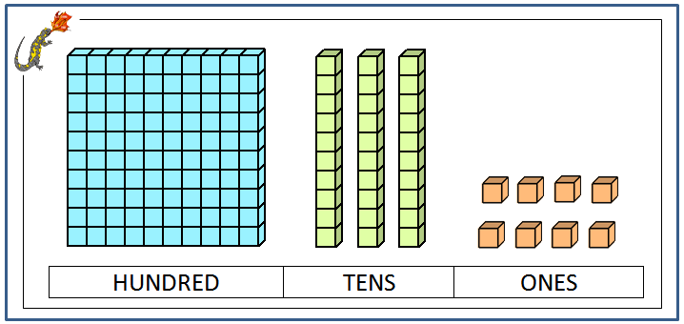
< Less than | The symbol < means that one number is smaller than the other number. | ‘Thee is less than 10.  3 < 10’
One-, two- or three-digit number | One-digit numbers are the numbers 0-9; two-digit numbers are the numbers 10 to 99; three-digit numbers are the numbers 100 to 999 | ‘Can you give me a two-digit number greater than 46?’
Operation | A mathematical process. The  four mathematical operations  are addition, subtraction,  multiplication and division. | ‘4 + 2 = 6. The operation is addition.  ‘
Place value | A system for writing numbers, in which the value of a digit is  defined by its position within the number. | ‘In the number 52 written in base ten,  The digit five has a value of 50 and the digit two has a value of 2.  ‘
Predict | A prediction is a reasonable guess as to what will happen. | ‘I predict the next number in the sequence will be 45.  30, 35, 40…’
Representation | A very general relationship that expresses similarities (or equivalences) between mathematical objects or structures. | 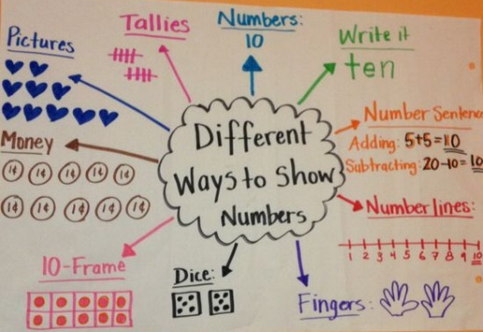
Rule | Rule is the procedure that a count must follow. | ‘The rule in the sequence below is add 2.  31, 33, 35, 37, 39’.
Sequence | A list of numbers or objects in a special order. | ‘The sequence below starts at 3 and increases by 4 every time.  3, 7, 11, 15’.
Twenty-first, twenty-second … | ‘Twenty-first, twenty-second…ninety ninth, one-hundredth’.
Twenty-one, twentytwo… | ‘Twenty-one, twenty-two, twenty three…ninety-nine, one-hundred’.
Addition and subtraction

Facts | A fact family can be defined as a group of math facts or equations created using the same set of numbers. | ’34 + 13 = 47  13 + 34 = 47  47 – 34 = 13  47 – 13 = 34’
Inverse operations | Opposite operations that  ‘undo’ each other. | ‘Addition and subtraction are inverse operations.’
Near double | When two numbers involved in an addition are close in value, such as 23 + 22. The numbers can be treated as exact doubles, followed by compensating. | ‘To calculate 23 + 22, I can use the near double strategy. I can double 22 and then add one more.  ‘
Regroup | To rearrange groups in place value to carry out an operation. | 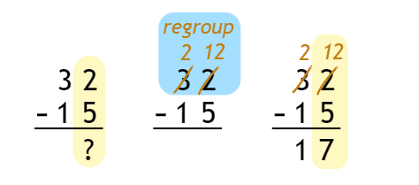
Renaming | Writing a number in an equivalent form, usually in terms of its place-value parts. | 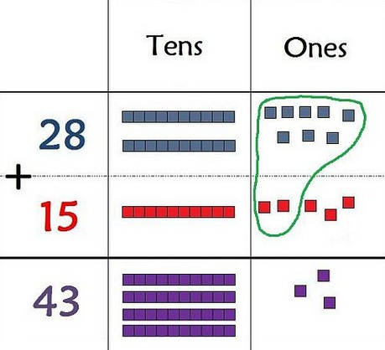
Multiplication and division

Division fact | Division number sentences related to times tables knowledge. | ’20 ÷ 5 = 4 is a division fact’.
Equal groups of | A group is an equal group if it has the same number of items as all of the other groups. | 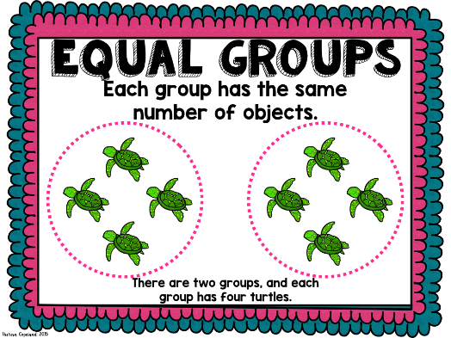
Left over | When dividing in maths, the groups can be the same size. Sometimes there may be a leftover. | 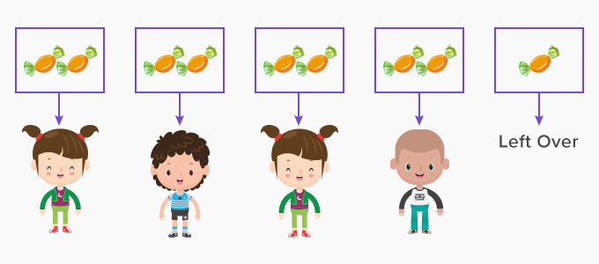
Multiplication fact | The answer to a multiplication calculation. For example in 3 x 3 = 9, the multiplication fact is 9. | ’10 x 7 = 70 is a multiplication fact’.
Multiplication table | A list that shows the results of multiplying certain numbers by each other. | 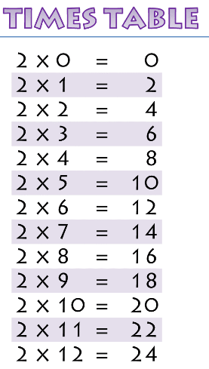
Times | An arithmetic operation that is the inverse of division. | ‘Four times three equals twelve’.
Fractions

Denominator | The number written below the vinculum in a fraction. In a measure context, it indicates the number of equal parts into which the whole is divided. In a division context, it is the divisor. | 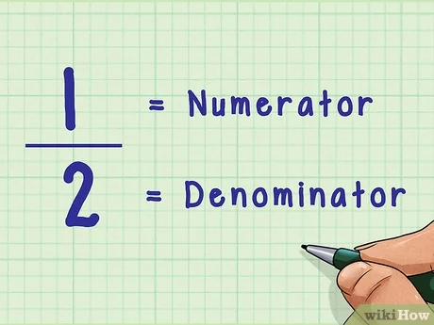
Equivalence | The condition of being equal or equivalent in value, worth. | 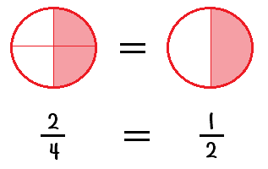
Mixed number | A number consisting of an integer and a proper fraction. | 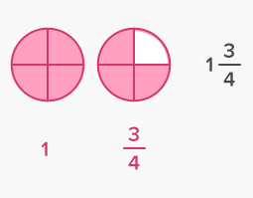
Non-unit fraction | A fraction with a numerator  greater than one. | ‘Two thirds is a non-unit fraction.’
Numerator | The number written above the vinculum in a fraction. In a measure context, it indicates the specified number of parts out of the whole. In a division context,  it is the dividend.
One of three equal parts | When a shape is divided into three equal parts, each part is called a third. | 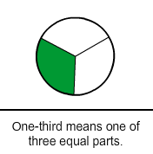
One third, two thirds | When a shape is divided into three equal parts, each part is called a third. Two of these parts are called two thirds. | 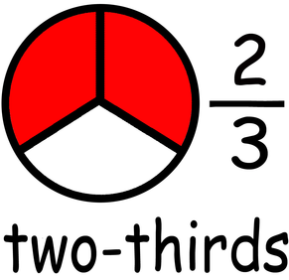
Two halves | Two equal parts of one whole thing. | 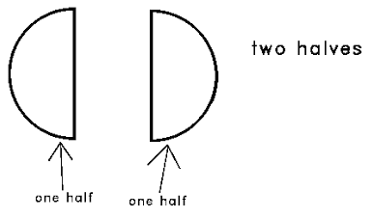
Two quarters, three quarters | When a shape is divided into four equal parts, each part is called a quarter. Two of these parts are called two quarters. Three of these parts is called three quarters. | 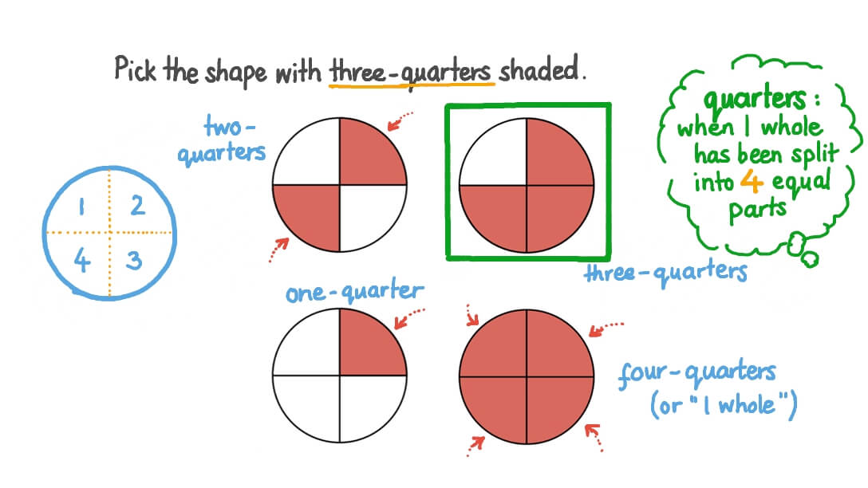
Unit fraction | A fraction with a numerator of one. | ‘¼ is a unit fraction.’
Vinculum | A horizontal line that separates the numerator and the denominator in a fraction. | 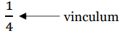
Length

Centimetre | A measure of length. It is about the width of a fingernail.  There are 100 centimetres in a metre.  The abbreviation is cm. | ‘The length of the line is 20cm’.
Furthest | At or by the greatest distance. | ‘The child in the red jumper is furthest away from the tree.’
Tape Measure | A length of tape or thin flexible metal, marked at graded intervals for measuring. | ‘Which iten would be the best to measure this object- a ruler, metre stick or tape measure?’
Weight

Gram | A metric unit of mass equal to one thousandth of a kilogram. | ‘This apple weighs approximately 100 grams’.
Capacity and volume

Millilitre | One thousandth of a litre. | ‘This small beaker holds about 60 millilitres of water’.
Temperature

Degree | A set change in temperature measured against a given scale | ‘The temperature at present is 16 degrees Celsius’.
Temperature | Measure of hotness or coldness. | ‘The temperature at present is 16 degrees Celsius’.
Time

5, 10, 15 … minutes past | 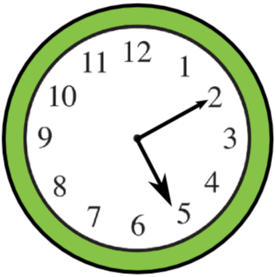
Digital clock | A clock that displays the time in numerical digits rather than by hands on a dial. | 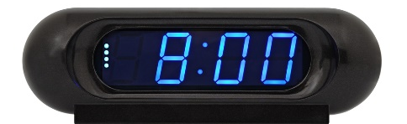
Fortnight | A period of two weeks. | ‘There are 14 days in a fortnight’.
Seconds | A unit of time. | ‘There are 60 seconds in a minute’
2d shape

Hexagon | A polygon with six sides and six angles. | 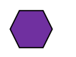
Line symmetry | A shape is symmetrical when it fits exactly onto itself when  folded in half. | 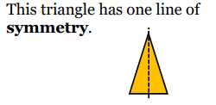
Octagon | A polygon with eight sides and eight angles. | 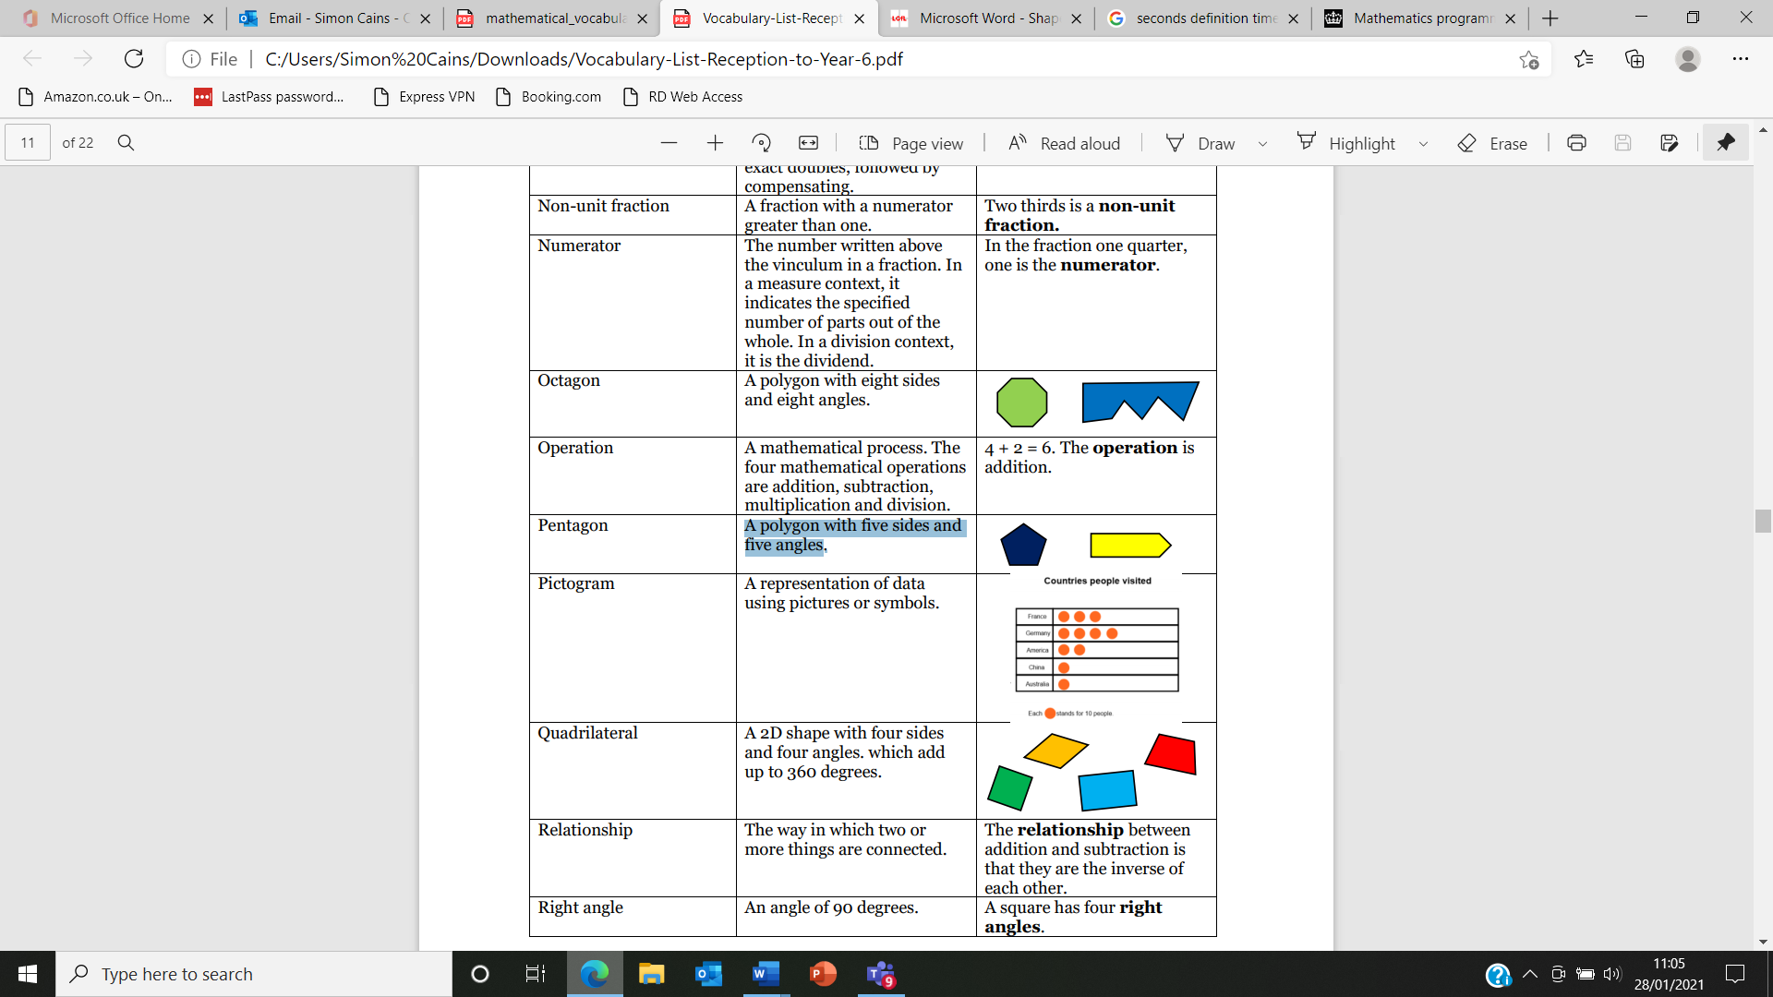
Pentagon | A polygon with five sides and five angles.
3d shape

Surface | The outside part or uppermost layer of a 3d shape. | 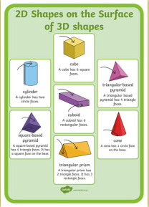
Position and direction

Right angle | An angle of 90°, as in a corner of a square | 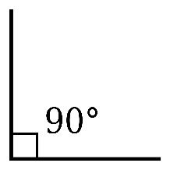
Straight line | A line that does not curve. | __________________
Statistics

Frequency | The number of times something occurs within a data set. | ‘4 pupils have brown hair. The  frequency of brown hair is 4.’
  Brown | Blue | Blonde
  IIII | III | I
Label | The horizontal label across the bottom and the vertical label along the side tells us what kinds of facts are listed in a graph. | 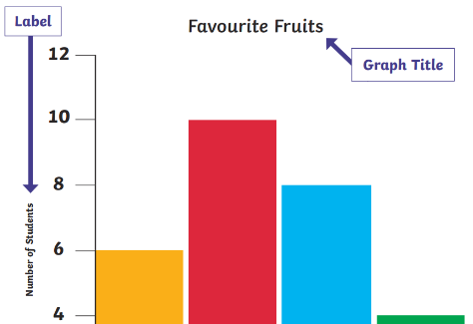
Least common | The smallest amount or number. | ‘No one caught the bus to school. It was the least common mode of transport’.
Least popular | The smallest amount or number. | ‘No one chose green as their favourite colour. It was the least popular option’.
Most common | The biggest amount or number. | ’20 children walked to school. It was the most common mode of transport’.
Most popular | The biggest amount or number. | ’15 children chose red as their favuorite colour. It was the most popular option.’
Pictogram | A representation of data using pictures or symbols. | 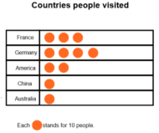
Represent | To present something in a certain way. | ‘We are going to represent the data you collected in a pictogram’.
Tally | A form of counting. Each tally is a vertical mark. After the fourth vertical mark, a fifth horizontal/diagonal mark is drawn to create a group of five. | ‘The tally chart shows that blue was the most popular colour.‘  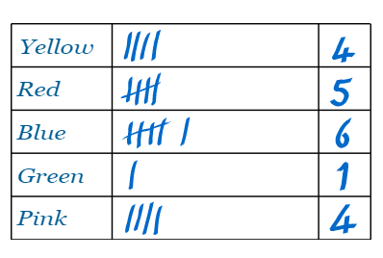
Title | The title of a graph tells you what the graph is about. | 

