Mathematical Vocabulary

Early Years



Mathematics vocabulary list EYFS
Maths is its own language. Sometimes that language looks like the written word and sometimes it looks like symbols, but it is a language and it must be learned for mathematical fluency and competency. If your child does not have a good understanding of key mathematical vocabulary, it can hinder them in making good progress in maths and in other areas of the curriculum.
At The Pines, we explicitly teach maths vocabulary, giving it a context and allowing children to apply it in a variety of problems.
Listed below are the key mathematical terms your child will learn this year. This is the minimum we expect children to learn; however, we know children are curious and will undoubtedly want to learn more and we encourage this.

Vocabulary | Definition | Example
Number and Place Value

Before | In front of or prior to. | ‘The number 3 comes before 5 on the number track’.
Between | A preposition that indicates location of an object with reference to two other objects, to the left of the first and the right of the second. | ‘4 is between 3 and 5 on our number track’.
Compare | Look for similarities and/or  differences between at least two  objects or sets. | ‘Let me compare these two sets – there are more red cars than blue cars.’  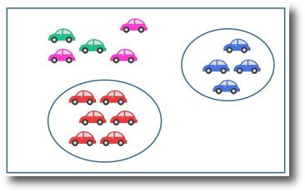
Count | Assigning one number name to each of a set of objects to determine how many there are. | ‘I counted the children in the group – there are four so we will need four pencils.’
Digit | A digit is a single symbol used to make numerals. | 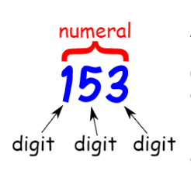
Estimate | To find a value that is close enough to the right answer, usually with some thought or calculation involved. | ‘Can you estimate how many counters are below?’  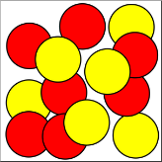
Fewer | A lesser amount – used when  counting discrete objects, i.e.  countable objects such as, pens, teddies, counters, etc. | 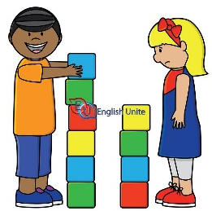  ‘The girl has fewer blocks than the boy’.
First | Before anything else. | 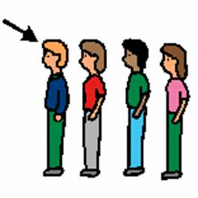  ‘Fred is the first person in line’.
First, second, third… | ‘First, second, third, fourth, fifth, sixth, seventh, eighth, ninth, tenth’.
Greater | When a quantity or number is bigger or larger than the second or rest quantities or numbers. | ‘10 is greater than 8’.
How many? | What number. | ‘How many counters are there on the 5 frame?’  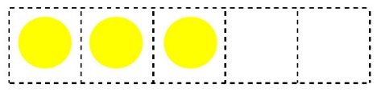
Is the same as… | Is equal to | ‘4 is the same as 3 + 1. It is also the same as 2 + 2’
Largest, greatest | The most in a set. | ‘The greatest number in the following set, 6, 3, 9 is 9’.
Last | Comes after all others in time or  order. | 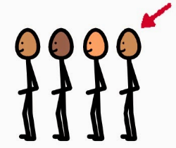  ‘Rory is the last person in the line’.
Less | A smaller amount or not as much. | ‘I have 9p and you have 3p. You have less money than me’.
Next | Comes immediately after the  present one in order. | ‘The next shape in my pattern is a square’.
Number | A count or measurement. | 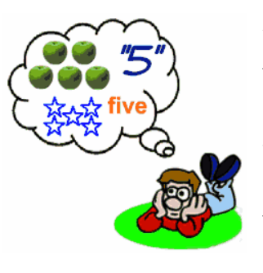
One, two, three…to twenty | ‘One, two, three, four, five, six, seven, eight, nine, ten, eleven, twelve, thirteen, fourteen, fifteen, sixteen, seventeen, eighteen, nineteen, twenty.’
Ones  Tens | ‘Numbers, such as 12, have two digits. Each digit is a different place value. The left digit is the tens' place. It tells you that there is one ten. The last or right digit is the ones' place which is 2 in this example’.
Order | Describes the placement of items according to given criteria or in a pattern. As a verb, to place items according to given criteria or in a pattern. | ‘I have ordered the chickens from biggest to smallest.’  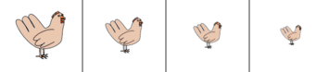
Pair | A set of two things used together. | ‘Socks come in a pair – one for each foot’.  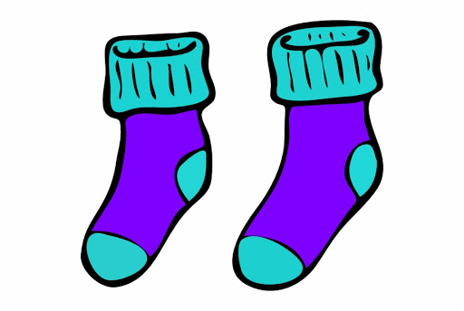
Pattern | A systematic arrangement of numbers, shapes or other elements according to a rule. | ‘The pattern is red, blue, red, blue, red blue’.  
Subitise | Instantly recognising the number of objects in a small group, without counting. | 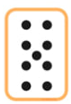  ‘There are 9 dots here. I worked this out without counting. I subitised’.
Zero | The number before one. It is neither positive nor negative. | ‘Zero comes before one on the number track’.
Addition and subtraction

Add | Carry out the process of addition. | ‘I can add two numbers together to find a total.  1 + 2 = 3’’
Addition | The operation to combine at least two numbers or quantities to form a further number or quantity, the sum or total. Addition is the inverse operation to subtraction. | ‘eight plus three is equal to eleven.  This is an addition question.’  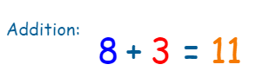
Altogether | In total. | ‘That will be £2 altogether please.’
Commutative | Either of two laws relating to number operations of addition and multiplication, stated symbolically: a + b = b + a and ab = ba. | ‘6 + 3 equals the same as 3 + 6. This is the commutative law.’  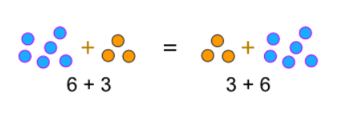
Double | To multiply by two or add a value to itself. | ‘Four is double two.’  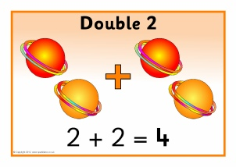
Less | A smaller amount or not as much. | ‘I have two footballs. You have 10 footballs. I have less’.  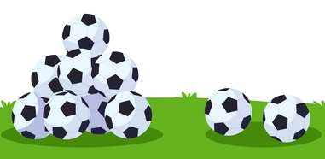
More | A greater amount. | ‘I have twenty apples and you have five. I have more.’  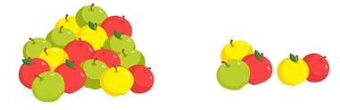
Sum | The result of one or more additions. | ‘The sum of five and three is eight.’
Take away | Used in the reduction structure of subtraction. To remove a number of items from a set. | ‘He ate three of the sweets so we need to take away three counters.’
Total | The sum found by adding. | ‘There are a total of five people at this table.’
Multiplication and division

Doubling | To multiply by two or add a value to itself. | ‘Ten is double five.’
Halving | One of two equal parts of a shape, quantity or object. | 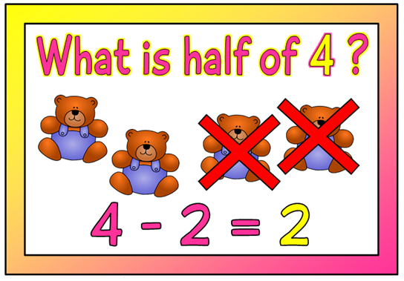
Number patterns | A systematic arrangement of numbers, shapes or other elements according to a rule. | ‘The number pattern is 2, 4, 6, 8, 10.’
Sharing | To distribute fairly between a given number of recipients. This is one model for division. | ‘I will share the crayons equally between the people at the table.’  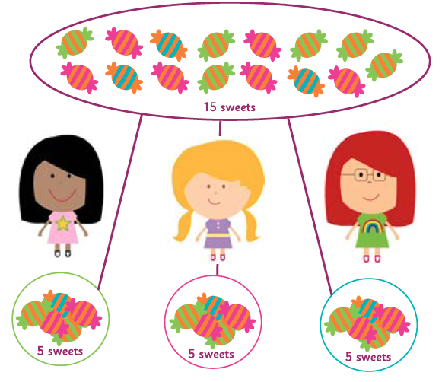
Fractions

Half | Either of two equal or corresponding parts into which something is or can be divided. | 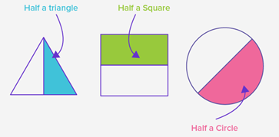
Parts of a whole | A ratio or a fraction that represents a relationship between a part and its whole. | ‘A cake has been split into two parts. One part has been eaten.’
Measurement

Compare | Look for similarities and/or differences between at least two objects or sets. | ‘I can compare these two sets – this set has more.’
Guess | An estimate or conclusion | ‘My guess is about 11’
Measure | To find the size of something in a given unit. | ‘How might we measure how much sand there is in the sand tray?‘  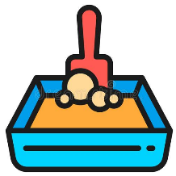
Size | An element’s overall dimensions or magnitude. | ‘The size of my shoe is smaller than my teacher’s.’
Length

Depth | The distance between the nearest end and farthest end of an object. | ‘Can you measure the depth of this box?’  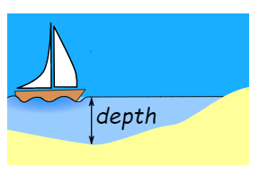
Height | The vertical distance from the top to the base of the object. | ‘The height of this object is 12 cubes.’  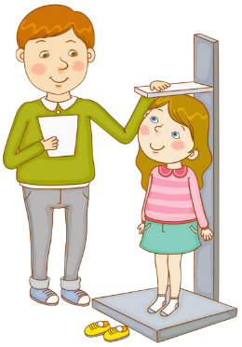
Length | A linear measurement. | ‘The length of my snake is shorter than yours.’  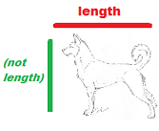
Long | An adjective used to describe length. | ‘I have a long piece of string.’
Short | An adjective used to describe length. | ‘This bed is too short.’  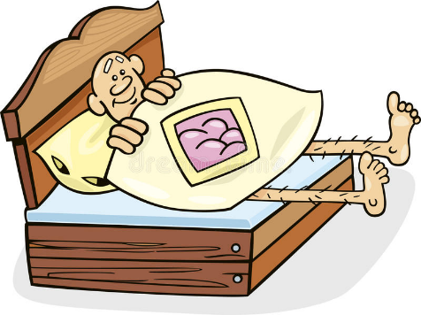
Tall | Measuring a specific distance from top to bottom. | ‘The children are not as tall as the teacher.’  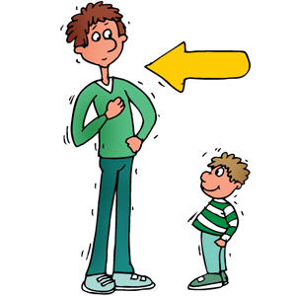
Width | The measurement of the distance of a side of an object. | ‘The width of this table is…’
Weight

Balances | A measuring tool used to weigh objects. It has two dishes hanging on a bar. Both dishes will be level when the contents weigh the same. Also, as a verb, indicates equivalence and equality. | ‘The objects in the balance are unequal in weight because the dish on the right side is lower down that the dish on the left side. The two objects balance which means they have the same mass.’
Heavy | Having a weight that is greater than that of another object. | ‘That box is heavy.’  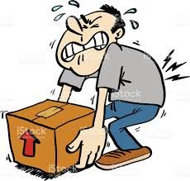
Light | Having a weight that is less than that of another object. | ‘The banana in the monkey’s hand is light.’  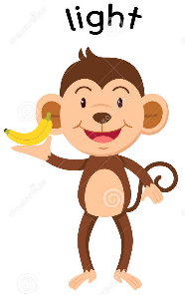
Scales | An instrument for weighing. | ‘Can you use the scales to weigh the cubes?’
Weigh | Find out how heavy something is. | ‘I have weighed the Lego model’
Weight | The force exerted on an object by gravity. | ‘The weight of this book is heavier than the pencil.’
Capacity and volume

Container | An object for holding or transporting something. | ‘What container will hold the most water?’  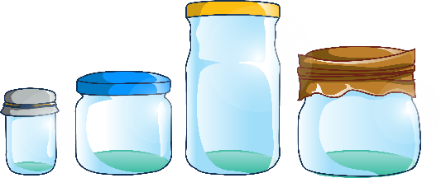
Empty | Containing nothing. Most  commonly used in the context of  measures | ‘There is no more water left in the jug – it is empty.’  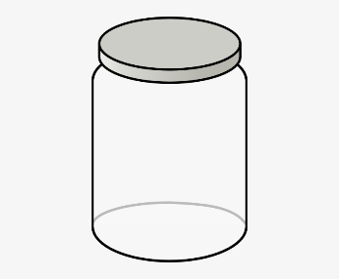
Full | Contains/holds as much or as many as possible; has no empty space. | ‘The juice carton is not full because I drank some.’  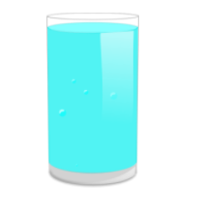
Time

Afternoon | The time from noon or lunchtime to evening. | ‘We are going to the forest this afternoon.’
Days of the week, Monday, Tuesday … | ‘Monday, Tuesday, Wednesday, Thursday, Friday, Saturday, Sunday.’
Early | Near the beginning of a particular time or period. | ‘You have arrived early today.’
Evening | The period of time at the end of the day, usually from about 6 p.m. to bedtime. | ‘You go to bed in the evening.’
First | Comes before all others in time or order. | ‘The first thing we are going to do today is to wash our hands’.
Hour | A period of time equivalent to 60 minutes. | ‘We are having lunch in 1 hour.’
Last | Comes after all others in time or order. | ‘The last thing we are going to do today is read a story.’
Late | Doing something or taking place after the expected, proper, or usual time. | ‘The teacher has arrived later than expected.’
Morning | The period of time between midnight and noon. | ‘Good morning everyone’.
Night | The period from sunset to sunrise in each twenty-four hours. | ‘You can normally see the moon in the night.’
O’clock | ‘The time now is 1 o’clock.’
Soon | In or after a short time. | ‘We are doing PE soon.’
Time | Related to duration. Measured in  seconds, minutes, hours, days,  weeks, months, years etc. | ‘After lunch it will be time for P.E.’
Today | The present day. | ‘The theatre are coming today’.
Tomorrow | The next day. | ‘Tomorrow, the weather will be snowy.’
Week | A period of seven days. | ‘Next week, we will be learning about farm animals.’
Yesterday | The previous day. | ‘Do you remember what we did yesterday?’
Money

Buy | Obtain in exchange for payment | ‘How much is that item to buy?’
Coin | A flat disc or piece of metal with an official stamp, used as money | ‘I have 5 coins here. I wonder how much I can buy from the shop…?’
Money | Any object that is generally accepted as payment for goods and services. | ‘That is a lot of money!’  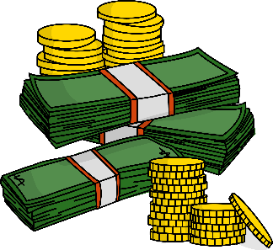
Pay | Give (someone) money that is due for work done, goods received. | ‘How much have I got to pay you for that?’
Penny/pence | A small sum of money. | 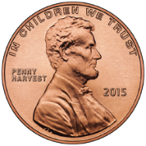  ‘That will be 3 pence please’.
Pound | Equal to 100 pence. | ‘The cake will be one pound please’.  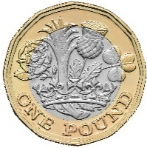
Price | The amount an item costs. | ‘What is the price of that please?’
Sell | Give or hand over (something) in exchange for money. | ‘I am not going to sell you this today’.
Spend | Give (money) to pay for goods, services | ‘How much money do you have to spend?’
Properties of shape

Bigger, Larger | Of considerable size. | ‘Which of these fish is the biggest?’  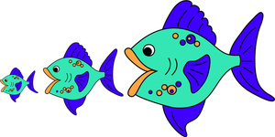
Curved | A non-plane surface of a 3-D shape.  Both cones and cylinders have  curved surfaces. | ‘This line is curved.’  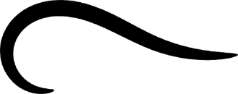
Flat | A level surface. | ‘The table has a flat rectangular surface.’
Hollow | Having a hole or empty space inside. | ‘This box is hollow’.  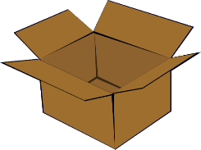
Pattern | A systematic arrangement of  numbers, shapes or other elements according to a rule. | ‘The pattern below is square, triangle, square, triangle.’
Repeating pattern | A design for decorating a surface composed of a number of elements (motifs) arranged in a regular or formal manner. | ‘Circle, rectangle, circle, rectangle…this is a repeating pattern of shapes’.
Round | A circular piece of something. | ‘This circle is round’.
Shape | A geometric figure such as a square, triangle, or rectangle. | ‘Which of these shapes has four sides?’
Size | An element’s overall dimensions or magnitude. | ‘The size of my shoe is smaller than my teacher’s.’
Smaller | Of a size that is less than normal or usual. | ‘Which of these fish is the smallest?’
Solid | Having three dimensions. | 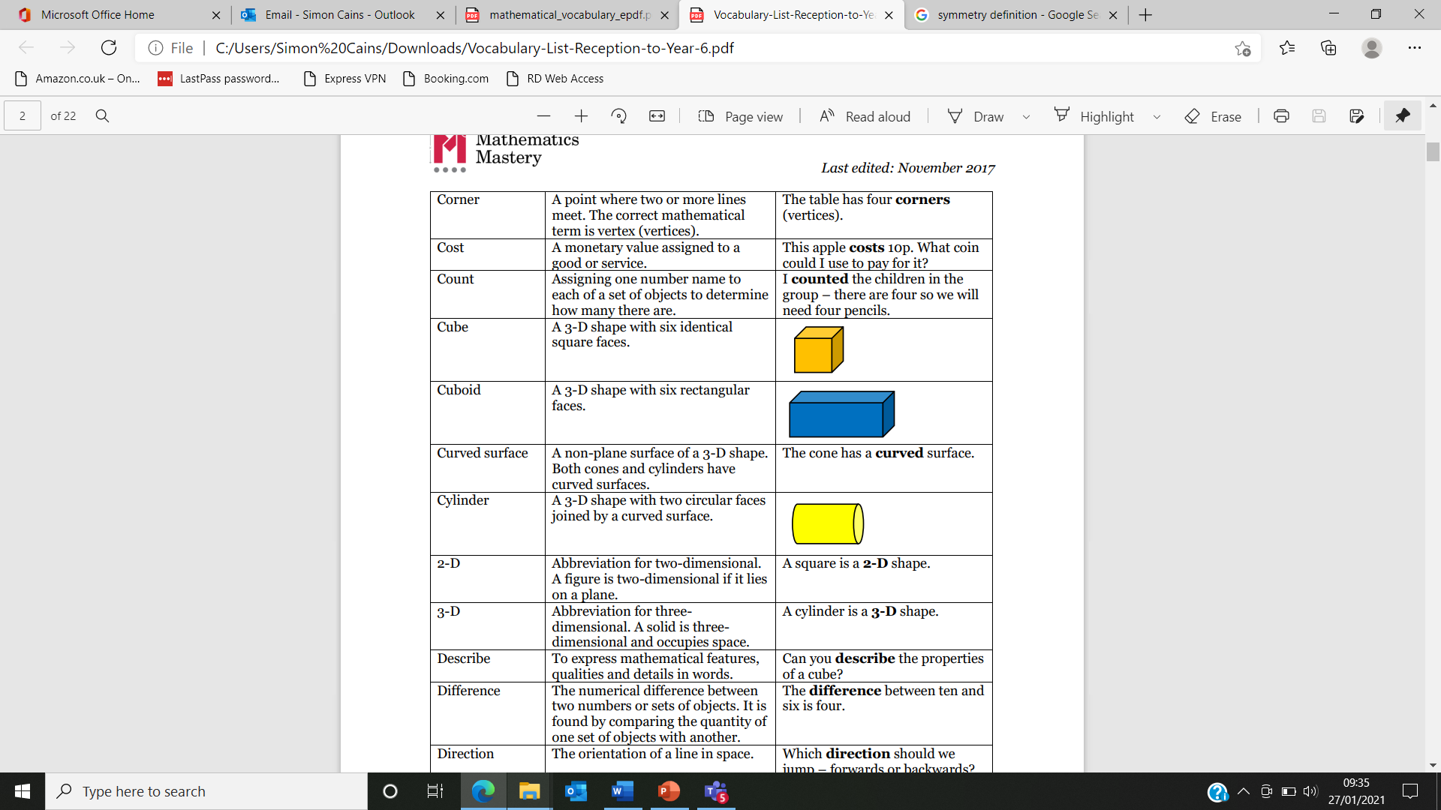  ‘This cube is a solid shape’.
Sort | Arrange systematically in groups. | ‘How could we sort these shapes?’
Straight | A line or movement uniform in  direction, without bends or curves. | ‘The edges of the table are straight.’
Symmetrical | A balanced and a proportionate similarity which is found in two halves of an object, that is, one-half is the mirror image of the other half. | ‘How can we see if this square is symmetrical? Let’s fold it’.  
2d shape

Corner | A point where two or more lines  meet. The correct mathematical  term is vertex (vertices). | ‘The table has four corners (vertices).’  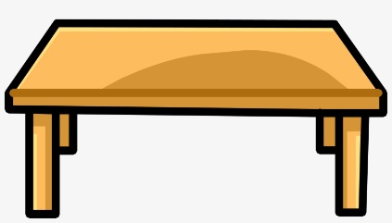
Circle | The name of a 2-D shape. A circle  has a curved side. | 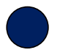
Rectangle | A quadrilateral with four right  angles. | 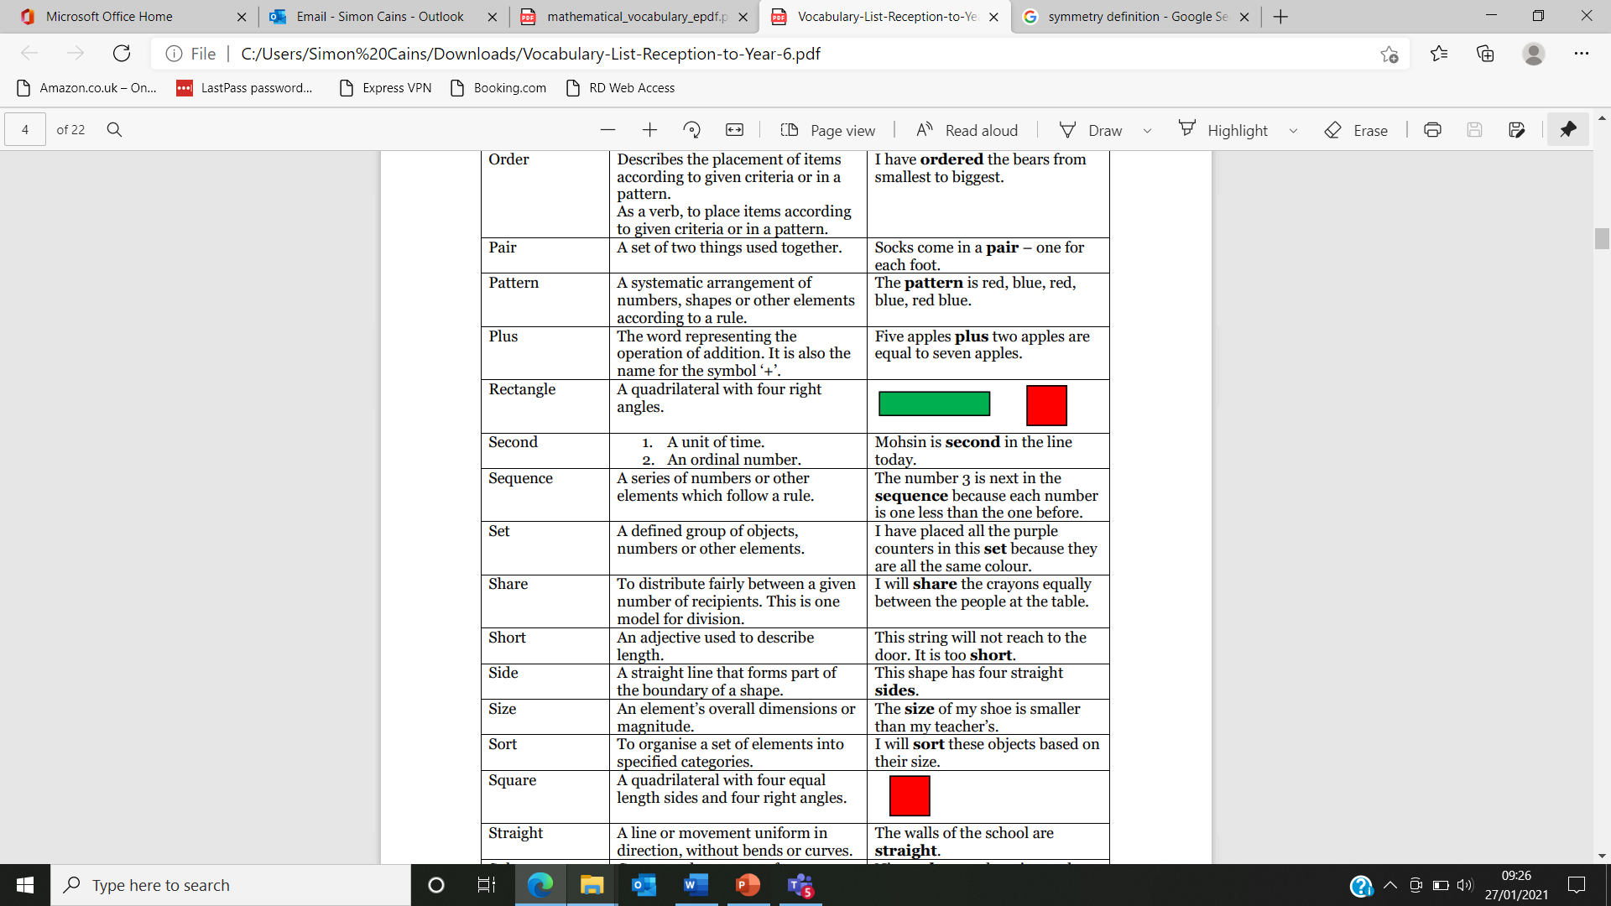
Side | A straight line that forms part of the boundary of a shape. | ‘This shape has four straight sides.’
Square | A quadrilateral with four equal  length sides and four right angles. | 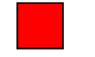
Triangle | A polygon with three sides. | 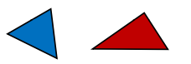
3d shape

Cone | A 3-D shape with one circular  plane face, which tapers to an  apex. | 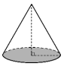
Cube | A 3-D shape with six identical  square faces.
Cuboid | A 3-D shape with six rectangular  faces.
Cylinder | A 3-D shape with two circular faces joined by a curved surface. | 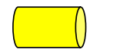
Edge | A line segment joining two vertices of a plane figure (2-D shape) and the intersection of two plane faces (in a 3-D shape). | 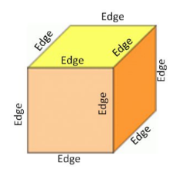  ‘A triangle has three edges and a cube has 12 edges’.
Face | One of the plane surfaces of a solid shape. | ‘A cube has six faces.’  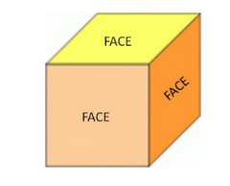
Pyramid | A 3-D shape with a polygonal  base and otherwise triangular  faces, which form edges with  the base, and which meet at  an apex. | 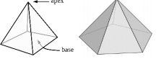
Sphere | A 3-D shape with a continuous surface, which is at all points equidistant from its centre. It has an infinite number of flat faces and straight edges. | 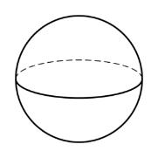  ‘A bowling ball is a sphere’.
Vertex, vertices | The point at which two or more  lines intersect. | ‘This shape has five vertices’.  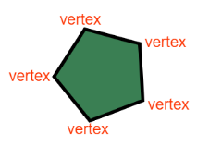
Position and direction

Above | ‘The ball is above the box’.  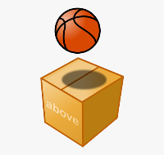
Across | ‘Walk across the road’.  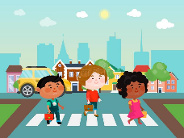
Along | ‘The hare ran alongside the tortoise’.  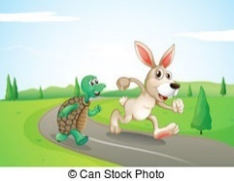
Apart | ‘Move apart from each other’  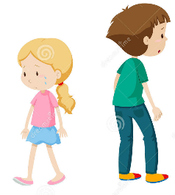
Around | ‘The plane flew around the world’.  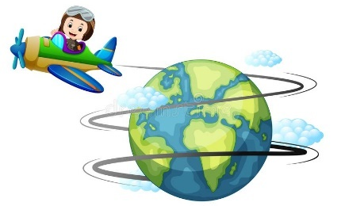
Away from | ‘If you see a snake, run away from it’.  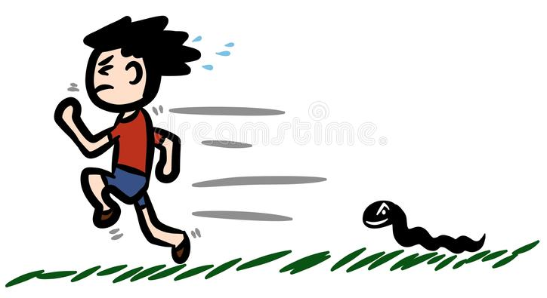
Back | ‘Please come in through the back of the house’.  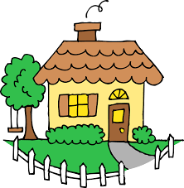
Backwards | ‘Move backwards until you reach the wall’.  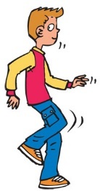
Behind | ‘The cat was behind the box’.  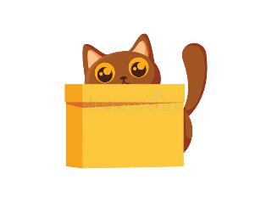
Below | ‘Below the tree, sat a little boy’.  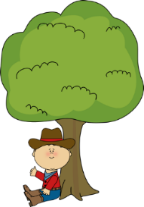
Bend | ‘Bend over and touch your toes’.  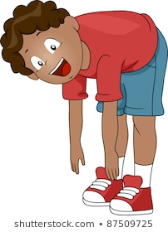
Beside | ‘The cat sat beside the chair’.  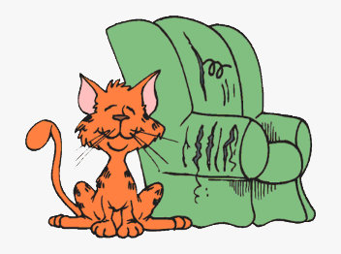
Between | ‘The red ball is between the two cardboard boxes’.  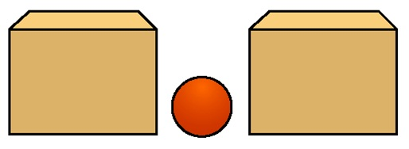
Bottom | ‘The little girl waved from the bottom of the classroom’.  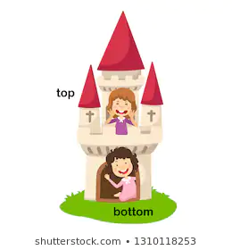
Close | ‘The children ran to the playground close together’.  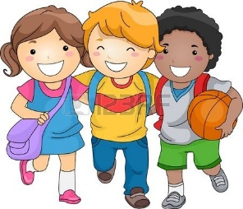
Corner | ‘Around the corner is the library’  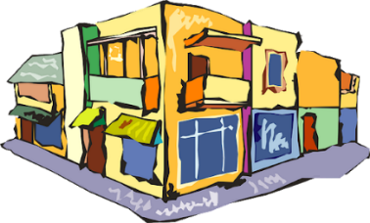
Direction | ‘Which direction do you think the postman needs to take next?’
Down | ‘The girl slid down the slide’.  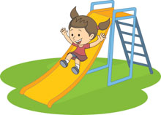
Far | ‘Birmingham is quite far away from our school.’
Forwards | ‘The girl walked forward through the corridor’.  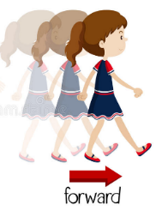
From | ‘The man moved the boxes from the van to the school.’  
Front | ‘The teacher was at the front of the class’.  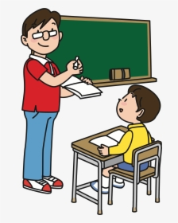
Half turn | A 180 degree rotation, i.e. ½ of a 360 degree or ‘full’ turn. | 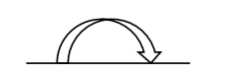
In | ‘The dog hid in the box’.  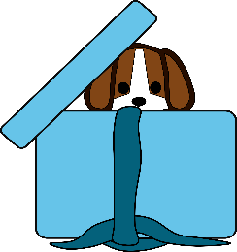
Inside | ‘The two boys slept inside their tents’.  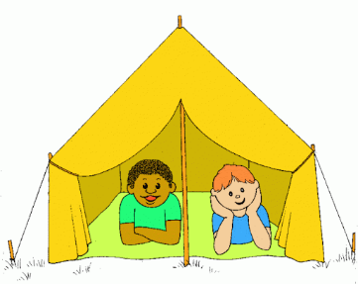
Left | ‘The green car is to the left of the right car’.  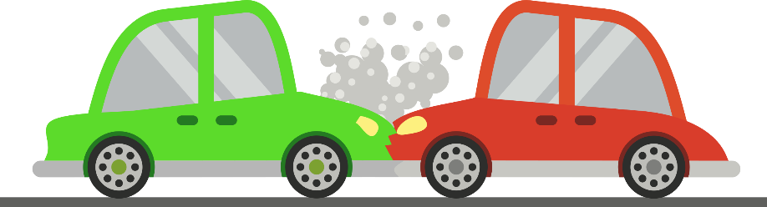
Middle | ‘The archer hit the middle of the target’.  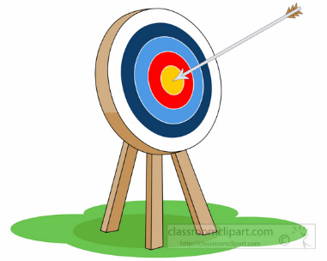
Movement | ‘Let’s stretch our arms really high in the air. Let’s make big movements’.
Near | ‘The bear was near the tree’.  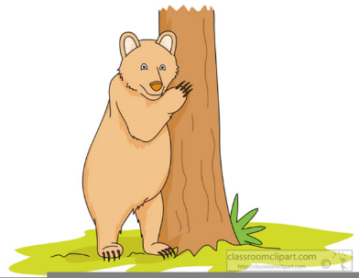
Next to | ‘The cat sat next to the ball of string’.  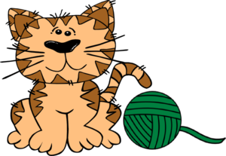
On | ‘The elephant balanced carefully on the ball’.  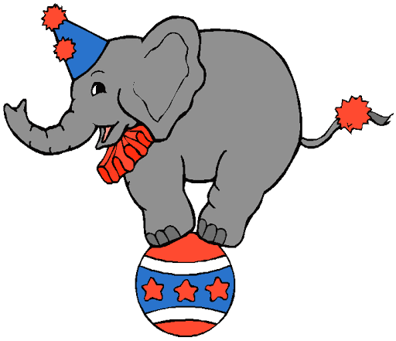
Opposite | ‘The man was on the opposite side of the wall’.  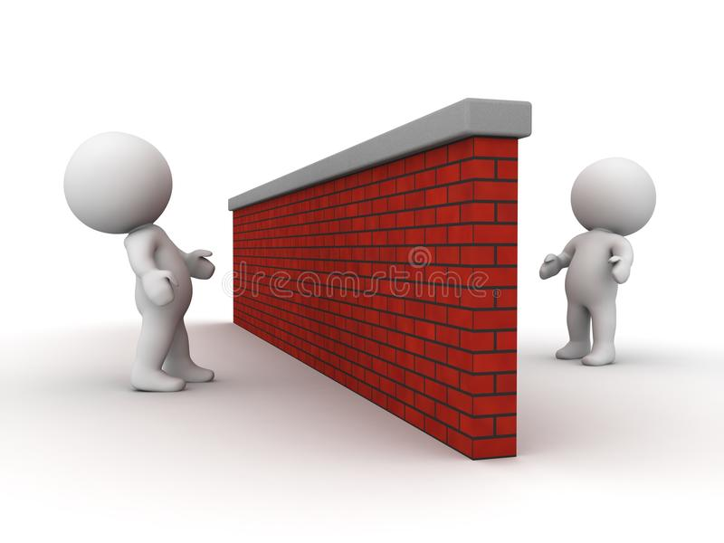
Outside | ‘The children played skipping outside’.  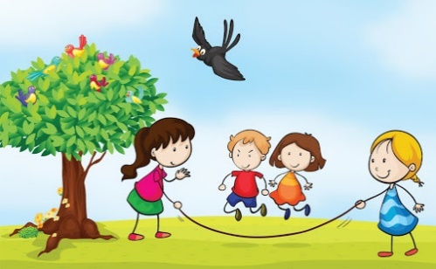
Over | ‘The horse jumped over the fence’.  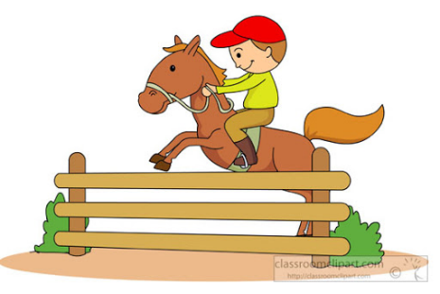
Position | Location, expressed either descriptively using positional  prepositions, or specified by  coordinates. | ‘The book is on the table. The clock is hanging above the board. This is their position’.
Right | ‘The purple fish is to the right of the green fish’.  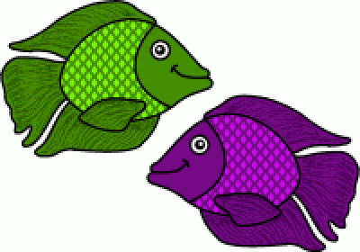
Roll | ‘Roll the ball along the floor’.  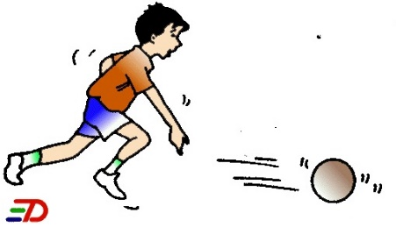
Sideways | ‘Tilt your body sideways. Can you still balance?’  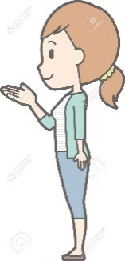
Slide | ‘In the dance, we need to slide to the right’.  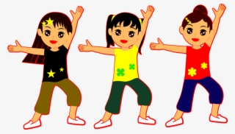
Stretch | ‘Before any exercise, we must stretch our muscles’.  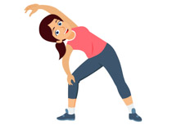
Through | ‘Chuck the ball through the hoop and into the net’.  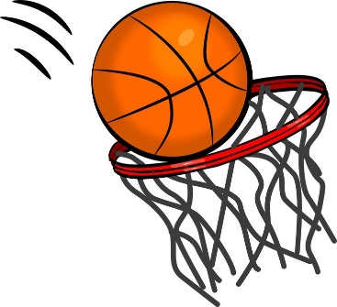
Top | ‘The explorer climbed to the top of the mountain’  
Towards | ‘The boy ran towards his mum at the end of the day’  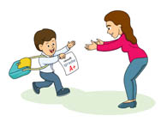
Turn | ‘The two girls were dancing and turned on the spot’.  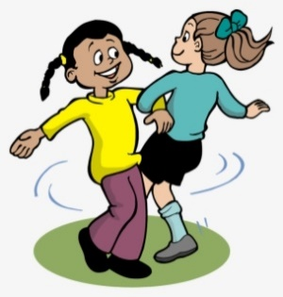
Under | ‘The boy hid under his blanket and read his book’.  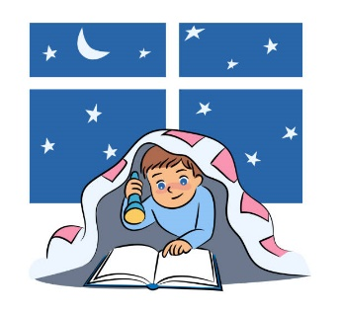
Up | ‘You can climb up the tree as long as an adult helps you’.  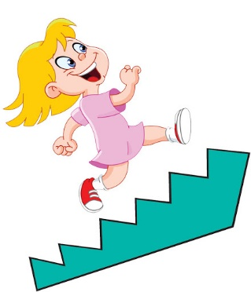
Whole turn | 360 degrees turn. | 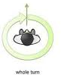
Statistics

Count | Assigning one number name to each of a set of objects to determine how many there are. | ‘I counted the children in the group – there are four so we will need four pencils.’
Group | To make equal size groups. | ‘I will group the crayons equally so that each person gets two.’
Set | A defined group of objects,  numbers or other elements. | ‘I have placed all the purple  counters in this set because they  are all the same colour’.
Sort | To organise a set of elements into specified categories. | ‘I will sort these objects based on their size.’

